M.D. of Greenview Library Board
Plan of Service 2021 – 2026
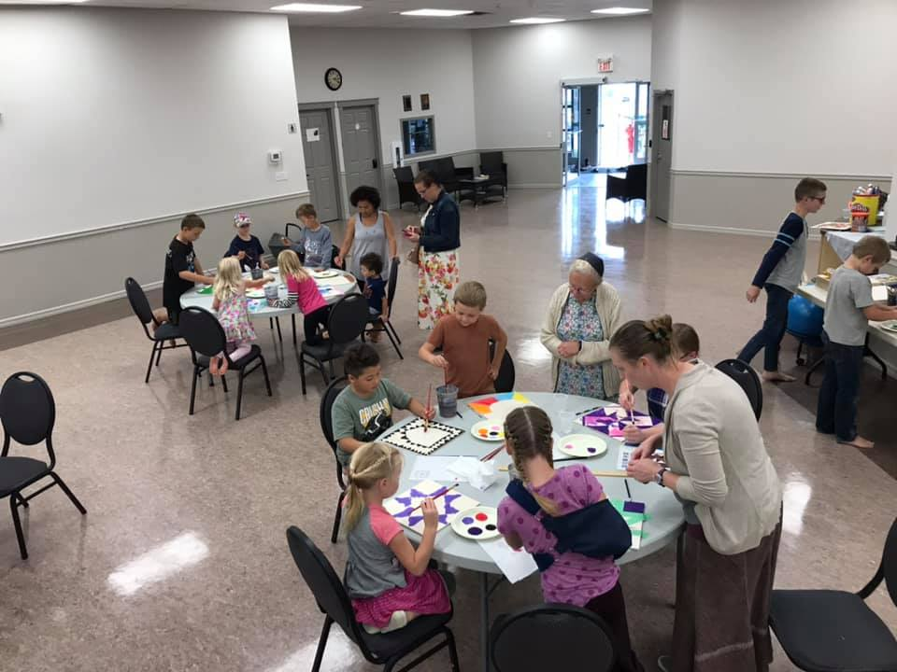
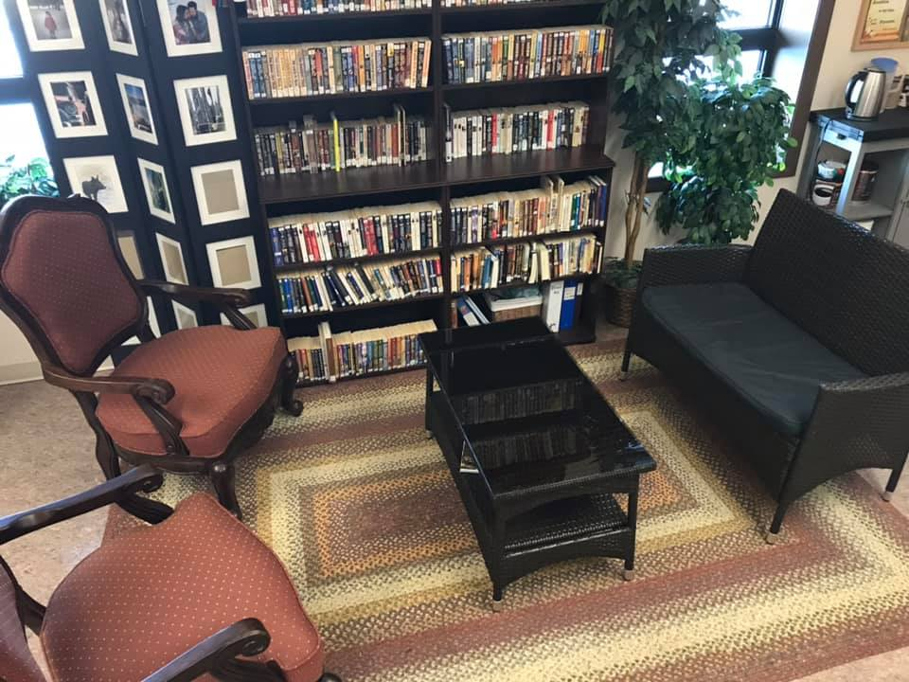
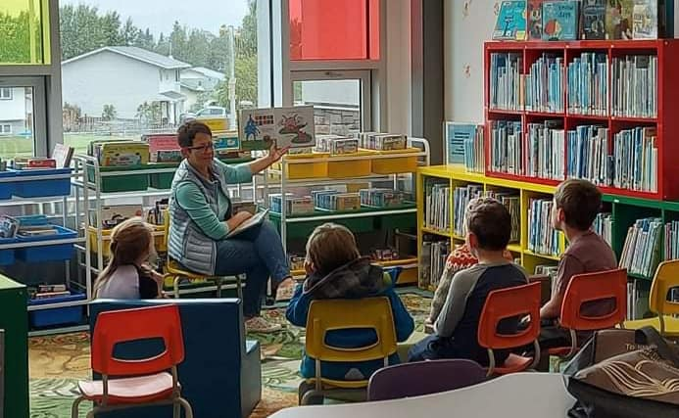
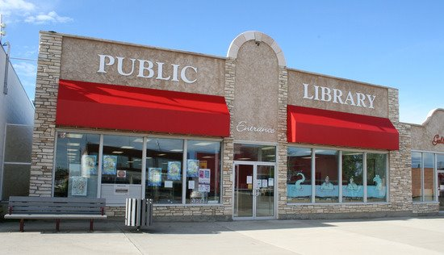
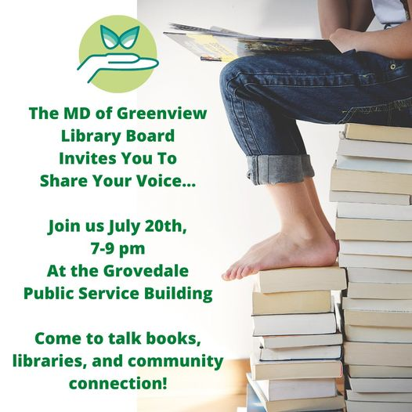

“Our Libraries: An Essential Community Service”

Final
- HMSorgen
September 23, 2021
Table of Contents

Summary 3
Rationale 3
Statement of Approval 3
Vision 3
Mission 3
Values 4
Strategic Goals 5
Goal 1: Ensure Infrastructure & Staffing are in Place to Deliver Effective Library Services 5
Goal 2: Provide Engaging and Powerful Programming 6
Goal 3: Increase Awareness of Library Services 7
Conclusion 8
Appendix A – Raw Data – Community Consultations 9

Summary
The MD of Greenview Library Board commissioned the services of local firm EmPower Up!, facilitated by Holly Sorgen, to consult with the Board and regional stakeholders, library patrons, and other residents in order to inform the organization’s Plan of Service 2021 – 2026.

The Board met June 12, 2021, to discuss Vision, Mission and Values. Community Consultations were held in DeBolt at the DeBolt Public Library on July 6, 2021, in Grovedale at the MD Public Services Building on July 20, 2021, in Valleyview at the Valleyview Municipal Library on July 27, 2021 and in Grande Cache at the Grande Cache Public Library on August 9, 2021. The cross section of attendees at the consultations included Library Board representatives, many of which attended all the sessions, library staff, library volunteers, local seniors, youth, and library patrons. Given the sessions were held during the summer, attendance was strong, indicating the community cares and supports the library system in the region.

The following Plan of Service 2021 – 2026, “Our Libraries: An Essential Community Service” encapsulates the plethora of ideas brought forward at the Community Consultations. Four general questions were used as the platform for the 2-hour Community Sessions. These included:
- What library services do you currently utilize? Why?
- If you do not use library services or only use them minimally what would make you use them more?
- What library services would you like to see more of?
- In 2025, a successful Library System is…

Rationale
The purpose of this five-year Plan of Service is to equip the Board with the resources, knowledge, and foundation to ensure the community’s needs are met. The term of this Plan of Service shall be from 2021 through 2026. As with all community-responsive documents, this plan is fluid and allows the Board to work with its stakeholders when needed and to alter direction when the community needs necessitate it.

Statement of Approval
Plan of Service Motion: Insert Motion here

Vision
The MD of Greenview Library Board is a thriving, collaborative, and innovative organization with a strong legacy of meeting the community’s needs via powerful, inclusive, and accessible library services.

Mission
The MD of Greenview Library Board achieves its Vision by providing:
- Library services that listen and are trusted
- Strong leadership via a responsive, committed governance Board
- Centralized information and documents
- Board capacity building and learning activities
- Yearly open houses/consultations/sharing opportunities

Values

- Inclusive & Diverse:
We value diversity and endeavor to ensure the unique needs of our communities are recognized and addressed as part of our service delivery.

- Collaboration & Partnerships
We believe in the power of community partnerships to extend the reach of library services and to ensure the needs of the community are being met.

- Trust & Openness
We are committed to being a safe place to openly share and discuss information, perspectives, and ideas.

- Passion
We are a board that is passionate about library services and our communities.

- Team
We understand that collective action is stronger than any one individual.

- Responsive & Connected
We are committed to remaining open, transparent, and welcoming to community ideas. We understand and embrace progressive change.

- Communication
We believe in regularly communicating with each other and the community.

- Fair & Equitable
We support all members of our communities accessing library services.

- Celebration & Appreciation
We understand the value of celebrating and appreciating our wins. We embrace our strengths and work through our weaknesses to be better as a collective whole.

Strategic Goals

Goal 1: Ensure Infrastructure & Staffing are in Place to Deliver Effective Library Services

Objective | Strategy | Action | Outcomes
To provide consistent library staff that is knowledgeable, connected, and passionate | Staffing needs are effectively resourced  Staff are provided training and professional development opportunities  Having a Staff and Board succession plan in place | Regular budget reviews, that support local staff and other community stakeholders who depend on library services  Staff and Board complete regular training and professional development sessions to stay up to date on technology, programming opportunities, etc.  Board reviews and engages in regular succession planning discussions to ensure libraries are effectively staffed and managed | Highly skilled library staff  Well informed and knowledgeable Board Members
To ensure the library infrastructure is suitable for the growth of library services in the region | Review the current space each library current occupies and determine whether it meets the needs of the community  Be responsive to and supportive of community requests for infrastructure as other funding needs | Consider current space, patrons, programming needs and community requests and determine if space needs to increase, be altered, be established, or taken mobile | Space that accommodates the needs of the community and library patrons  Increased # Of members  Increased # Of programs
 | Support communities in exploring the development of libraries services where they are currently none | Support local “spark plugs” in developing library service models for their communities  Support community and local libraries to explore/develop off site, mobile or other ways to deliver library services | # Of community partners  # Of new services developed  # Of out of the walls service delivery methods
Facility ideas worth exploring: Library in a Seniors Facility, indoor playground in the library or co-located, co-location in schools, co-location in recreation centers, Learning Commons, Cow Bus Mobile services, Book Boxes in communities, book/resource lockers in itinerate locations.

Goal 2: Provide Engaging and Powerful Programming

Objective | Strategy | Action | Outcomes
Provide programming that engages young parents in local libraries | Continue to deliver programs that are well attended by caregivers and their children | Continue or explore opportunities for Rhyme Time, Lego, Munchkins, Mom’s Night, Kids Music sessions, Reading nook, etc. | Increased # Of programs  Increased # Of members  Increased # Of attendees  # Of attendees from historically underrepresented groups  # Of collaborations for program delivery  # Of subject matter experts engaged
 | Identify new programs that are interesting and will engage young parents and their children
Provide programming that engages seniors in local libraries | Continue to deliver programs that are well attended by seniors | Continue or explore opportunities for Knitting, Coffee, Cards & Connections, Scrabble, Intergenerational activities where seniors share with youth/children, etc.
 | Identify new programs that are interesting and will engage seniors
Provide programming that engages youth in local libraries | Continue to deliver programs that are well attended by youth | Continue or explore opportunities for Lego nights, Book Face Fridays, Reading Challenges, Graphic Novels – i.e., “Community Name” Comicon, etc.
 | Identify new programs that are interesting and will engage youth
Provide programming that engages a diverse population (Indigenous, New Canadians, Mennonite, cultural and other ethnic groups represented in the communities we serve) | Continue to deliver programs that are well attended by diverse populations | Continue or explore opportunities to collaborate with cultural groups, associations, etc., to deliver programming such language classes, traditional learnings, celebrations, arts, and culture, etc.
 | Identify new programs that are interesting and will engage diverse populations
Provide programming that enhances collaboration with subject matter experts and/or organizations | Continue to collaborate with subject matter experts to deliver programs that are well attended by the community | Continue or explore opportunities for topic-oriented programming, workshops, sessions such as cake decorating, pumpkin carving, art, painting, music, guest artists and musicians, writing programs, vehicle & motorcycle enthusiasts, cooking, farming, gardening, poetry, wine, beer making, cheese making, Yoga in the Park etc.
 | Identify new collaborations with subject matter experts to deliver programs that are well attended by the community(s)
Provide programming that is accessible to the public | Continue to revisit hours of operation to accommodate the needs of the community(s) | Explore the option of increasing or changing hours for special events and/or start with revised hours to “test the water.”

Goal 3: Increase Awareness of Library Services

Objective | Strategy | Action | Outcomes
To increase awareness of library services to encourage community use of the facilities, resources, books, and networks | Traditional Advertising | Continue to utilize posters, newspaper, radio (when needed) to enhance the “library brand” and awareness | Increased # of memberships  Increased # of partners  Increased attendance at library events  Board member involvement and activities
 | Social Media Activity | Continue to increase social media presence on chosen platforms to appeal to wider demographics  Create library generated content and encourage organic content via follower connections, sharing and mentions
 | Hours of Operation | Continue to increase hours of operation, if required, to encourage a wider demographic of patron to visit the library for resources, sessions, workshops, etc.
 | Collaborations and Partnerships | Continue to collaborate with other community organizations, linking and networking with educators, service clubs, service providers, government, etc. to increase the overall reach of library services
Explore opportunities to do regular Library Spotlights or Showcases in local media – i.e., Showcase a program, a volunteer, a member, an event. Live Displays at Tradeshows, and Community Events: Host Open House Events.

Conclusion

The MD of Greenview Library Board is committed to supporting effective library services to not only the communities and residents it serves, but to all Albertans. Regular dialogue with local stakeholders, partners, service providers and library patrons will help to extend the reach of library services into the community and continue to grow the overall relevancy, and sustainability of libraries in the region.
Appendices

Appendix A – Raw Data – Community Consultations
Note: The notes included here were captured as a point in time conversations. We honour and recognize that this conversation will continue and evolve as we grow toward our next Plan of Service.
DeBolt Consultation, July 6, 2021

- What makes your library successful? (Programs, role in Community, who it serves, how it serves…)

- Access to computers, online, services – inclusion
- Librarian is awesome – Rachel – friendship
- Knows community needs
- People who come here
- Book Boxes in the community
- Very involved
- Summer reading
- Lots of connections with different people
- Diverse population served and supported
- Sensitivity of the services
- Summer student
- Programs – LEGO, bus drop off
- Internet based programs i.e., knitting club
- Think outside box for diverse appeal i.e., cake decorating, pumpkin carving, chili cookoff
- Partner with other groups
- Help find books that interest and encourage reading
- Opportunity for work experience Students
- Welcoming environment
- Tutoring
- E-reading #’s
- Host local artists
- Donated art (philanthropic connection)
- Board supports dollars, verbal encouragement, not restricted
- Friends of the library (8 members)
- Seek out champions – an alternate to sports
- Writing program for kids to make/write books
- Entered story writing at Grande Prairie Public Library
- Location
- Rhyme time
- Homesteaders’ program
- A hub
- Munchkins upstairs – crossover
- Scrabble afternoons
- Autonomous
- Promoting other community programs

- What would make it more successful? (Programs, people, infrastructure, etc.)

  - Teenager engagement (book face Friday movement)
  - More room – expand in building
  - Space for tutoring etc. /allow programs to expand
  - Expand social media platforms – Instagram, TikTok
  - Cross connections i.e., Sports books, magazine, topics of interest
  - Change culture – how community sees libraries – we are the hub
  - Social fabric
  - Re-engage after COVID
  - Book club
  - Mom’s night for reading
  - Shelves too small, running out
  - Sound carries
  - Break the barriers i.e., males’ program to connect with them
  - Non-academic library
  - Active space
  - Comfortable furniture
  - Intergenerational activities – kids and seniors
  - Awareness
  - Displays/info at community events i.e., fair
  - Library showcase in community calendar – a program – a volunteer – a member library advocates – the influencers on their mediums (social media too), live displays/visual/call to action
  - Prizes from local businesses – cross promote

- In 2025, your library is …. (Members, programs, services, reputation)

  - Library with seniors’ facility and indoor playground (co-located) Community Hub
  - Indoor playground
  - Space to expand
  - Comfortable and welcoming
  - Partnerships to build community
  - People feel welcomed
  - All libraries are more connected
  - Sharing, working together
  - Rachel is cloned
  - The place to go to find something out
  - It’s for everyone – the library is whatever you need it to be
  - Adaptable to conditions – resiliency

Grovedale Consultation, July 20, 2021

- What makes your library successful? (Programs, role in Community, who it serves, how it
serves…)

- Services Grande Prairie Public Library Book Club
  - Grande Prairie Public Library Computers
  - Books
  - Kids Music
  - Library of the things i.e., snowshoes
  - DVDS
  - LEGO in the library
  - The reading nook
  - The fireplace
  - School library (kids love it, time, library visits programming – parent driven)
  - Games
  - Paint nights
  - Cow bus

- What would make it more successful? (Programs, people, infrastructure, etc.)

- Computers – computer training
- Space to study – need better broadband
- LEGO
- Barbies
- Arts and crafts
- Reading circles
- Demographics – older kids, youth, young families, empty nesters
- Program to study learners, drivers
- Learn to sew classes
- Study groups
- Babies best start
- Young adults moving back
- A learning commons concept – lessons etc., not a typical library, coordinator/facility
- Social connection
- Students who are home school or schooled elsewhere to connect to others in community – to establish roots
- Space without connection – de-stress
- Music
- Home alone, babysitting course etc.

- In 2025, your library is …. (Members, programs, services, reputation)

- Learning commons with programming
- Communal space
- Use community hall? Hub: space not conducive
- Parents connections
- Youth engagement
- Library – can connect over books (Community based around library – friendship club)
- Coffee
- Cards
- Socials
- Summer kids’ programs (reading/reading circles)
- Summer reading challenge
- Book fair
- Book clubs
- Graphic novels group – Grovedale Comicon
- Yoga in library – demographics
- Audiobooks
- Engage male demographic of programs i.e., vehicles, motorcycles, vegan cooking, tattoos etc.
- Smaller scale: connection spot – I want to learn… I’m an expert at….
- Mobile services?
- Learning other language
- Indigenous teachings
- Astronomy classes/groups
- Farming programs
- 4-H collaborative
- Music hour
- Partnerships to deliver programs
- Appropriate space to use
- Free access, programs, groups, etc.
- MD grant to assist with free economical access
- MD advocate for use
- Grovedale Ag society and Rec board – hall – rink – different approach? Grant program for review?
- Capacity building for groups to partner to deliver
- Grovedale friends of the library
- Committee – rise funds for programming could work with school library (room to add on) to expand its’ offerings as first steps to create Business Case – your Greenview elected officials, will be 2 after the Municipal elections in October
- Volunteer facilitators
- Programs offered, i.e., Reading circles – elderly reading to kid’s history passed on
- Social activities
- Cultural learning and sharing
- Dolly Parton’s imagination library
- A permanent home
- Empty classrooms – learning commons to start – buy-in, Peace Wapiti School Board – a library capacity right now, volunteers, dollars allocated to EAs – opportunity to discuss
- In school library?
- Possible youth council
- Possible collaboration with other Greenview libraries – i.e., other librarians come to Grovedale to do programming

Valleyview Consultation, July 27, 2021

- What makes your library successful? (Programs, role in Community, who it serves, how it serves…)

  - Avid reader
  - Ton of electronics
  - Audiobooks
  - E-books
  - Magazines
  - News
  - Engage youth in reading
  - Strong online reading
  - Summer reading club
  - Take and makes
  - Pre-covid: audio books-listen while driving more e-audio books preferred
  - Young children – toy library, art shows
  - Programming
  - Libraries open same as schools would be great
  - Videos
  - Online books – able to find and read series
  - Covid re-opening – need to reengage
  - Topic areas to engage kids/non-readers?
  - Field trips
  - Book cards at desk – read books – treasure
  - Rhyme time – adult community learning – newcomers
  - Feel safe/warm

- What would you use? See more of …

  - Access – lockers, connection, consistent hours
  - summer reading
  - E-audio books
  - Art shows
  - Enjoy the quiet
  - Poetry readings
  - LEGO
  - Geo-caching
  - Pokémon
  - Give library cards to kids-bring parents in – traffic – awareness/education – the carrot
  - Fill school library gaps
  - Increase as a hub place
  - Evening hours – appeal to workers
  - Tutoring, computer classes etc.
  - Grow potential connections with FCSS, community agencies – assess community needs, ideas, share time, money etc., – plan to balance opportunity – time, special events
  - The gallery – multi-use
  - Accessible – time, location, space/access for people with mobility issues i.e., Cocoa corner
  - More senior events (scrabble, cards) scheduled visit partners i.e., Shepherds village
  - Library go to them – rhyme time for seniors
  - Bring youth together with seniors
  - Speedier internet: well, used
  - Walking with families
  - Enhanced use for business, gov’t programs
  - Buy a book for a dollar
  - Mystery bag of books explore the genre based on an interest – top author, could do with surplus books to purchase
  - Blind date packs
  - Diapers: comfortable for parents
  - Connect with Indigenous population – build bridges partner, engage, events awareness
  - Walking story on the trails – visit, read, complete, enter for a prize – increase engagement differently (1 @ the narrows)

- In 2025, your library is …. (Members, programs, services, reputation)

  - Partnerships
  - Demographic engagement – i.e., Male, seniors, graphic novels youth, Indigenous, cultural groups, etc. responsive to census data
  - Hands on workshops – skill, topic, cultural
  - Hub of the community
  - A warm safe place
  - Strong, supportive, engaging staff
  - Library boards sharing
  - Library staff sharing
  - Strong, supportive, engaging staff
  - Library, gallery, and community resource centre co-located with space for growing essential skills – a true (hub) of services
  - Passing down traditional knowledge
  - Do an assessment of what people need now, post COVID – new skills people are seeking
  - All ages welcome – infant to elderly
  - Ask the question – “why?”
  - Connected/networked staff – referrals accessing resources connect the dots
  - Responsive/aware board
  - Regularly reach out to potential partners/referral sources i.e., sports teams’ coaches – we have x for you about your interest areas
  - Learning supports – i.e., Math supports – support different age kids and parents to learn and grow math skills
  - Multi-use facility
  - Rapid readers
  - Community libraries – not just the books
  - Education/awareness/dispel myths
  - Virtual offerings – zoom in the experts
  - Other users

Grande Cache Consultation, August 9, 2021
- What makes your library successful? (Programs, role in Community, who it serves, how it serves…)

- Track pack service to get books from elsewhere
- Take out books
- DVDs
- Use with students -library puts packages/themed
- Grande cache reads
- Drop-in 2x weekly
- Excellent staff – helpful skillset to assist and accommodating
- Host book clubs on site
- Author presenters
- Library as a hub – an asset for prog tots to seniors
- Public access to computers!
- Valued service as a partner
- Hold community meetings
- Inclusive, culturally diverse
- Younger children’s programs
- Bee summer – observation hive – appeal to more people
- Free Wi-Fi – kids, youth, online/lives
- Use of the provincial system – access to national network
- New books on Facebook – the historical pics
- Create sense of community and belonging
- Not just books anymore
- Online learner testing – proctor exams
- Tutors utilize library to do tutoring
- Info distributed – Facebook, posters on boards, emails, newspaper (print, digital – every 2 weeks)
- Summer reading program
- Families
- A space for moms to gather and connect
- Story walk

- What would you use? See more of …

- Coffee bar
- Possible co-locate/mobile – rec centre
- 3d printer – makerspace: appeal to diverse group
- Appeal to more teens: tech/3d, etc. might appeal
- Travelling art installations – increase demand
- Moms and kids programming – toddler time
- Origami
- LEGO club – appeals to all demo
- Active older seniors target to attract
- Wide continuum of activity programming – wood crafting, paper tooling, etc. subject specific – the appeal?
- Partner/collaborate with other organizations on teachings i.e., Crystal Chowace – offer to school, possibly build into evening
- Active population – harder to appeal to
- Evenings?
- Music/musicians – focus night – foster as cultural learning, explore music
- Topic-specific programming
- Career highlights – appeal to youth
- “Bibliobus” – mobile library services: library bike
- Littletown library – central park
- Opportunity – mobile services in Co-Ops & communities – consultation as world re-opens
- Story walk
- Book bundles
- Activity book bags – a new group
- Provide books by request – book bundles, etc.
- Themed activity book bags – specific demo
- Ideas -action
- “blind date”
- Pokémon/geo caching – library stop
- Hindered by lack of space to do things like library of things
- Limited by time – not later than 8 p.m.
- Run 2 programs at once, but can be overwhelming – would be great to offer
- Community meetings for groups
- Book clubs – kids, adults, seniors – fall cookbook club
- The space – the old pool would be a great space
- Décor on the walls, showcase art, etc.
- A one stop shop – collocated services rec. centre, coffee, library, etc.
- Could partner more i.e., Rec. centre after school prog. 1x/week – a different catchment increase utilization
- Pursue strategic partnerships/collaborations -welcome the invitation/conversation
- Subject matter experts – i.e., Parks/env. Bat program, etc.
- Be open to working together
- Genealogy – family history – access to e-resources to connect to
- Access to equipment to view historical films – closest is Hinton
- Space for things like art: paint nights, etc. depending on timing – evening/weekends
- Craft workshops and training

3. In 2025, your library is …. (Members, programs, services, reputation)
- Speaker series – multi-use for lots of groups
- Staff – sufficiently money for staff
- One stop shop – best location for Grande Cache – connected and accessible
- Bigger, Better and Better
- Expanded further for hours and offerings
- Indigenous population openly engaging with library services
- Even better communication with the community – community buy-in
- Encourage community input
- Utilize newspaper – use for surveys, info gathering
- Connections to archives for books to preserve
- Enhanced community partnerships community liaison function
- Latest technology
- Kids connect to books
- Increase usage
- Diverse members/users
- Mobile library services: we can come to you i.e., Whispering pines
- Succession plan
- Continued access to larger system
- Linkages with other individuals/sectors – i.e., Visitor services, library on hand on topics
like dinos

